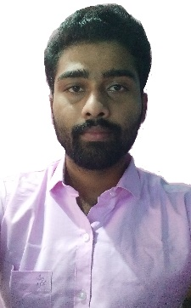

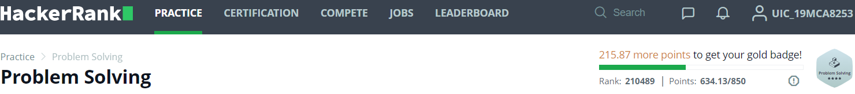

**JYOTIPRAKASH NAYAK**

Address: Khurantutha, Ersama, ODISHA- 754139

E-mail: 19MCA8253@cuchd.in

Phone: +91 7978365309

LinkedIn: https://www.linkedin.com/in/jyoti-prakash-nayak-a56229194/

**PROFESSIONAL SUMMARY**

A well-prepared creative and goal oriented graduate having excellent communication, problem-solving and leadership skills with enthusiastic to explore suitable avenues in Computer Science Engineering while developing advanced projects with efficiency and quality.

**TECHNICAL COMPETENCIES**

JAVA **|** PYTHON **|** Kotlin **|** C++ **|** C **|** C# **|** PHP **|** Node JS **|** HTML **|** CSS **|** JavaScript **|** Linux **|** MySQL **|** Mongo DB **|** PLSQL **|** Cyber Security **|** XML **|** DevOps **|** Machine Learning **|** Cloud Computing | DevOps | Arduino | IOT | Android

**INTERPERSONAL SKILLS**

Team Leadership **|** Management & Coordination **|** Decision Making **|** Motivator **|** Confidence **|** Determination

**INTERESTS & HOBBIES**

Yoga, Pranayama, Meditation **|** Chess, Rubik Cube **|** Coding **|** Travelling **|** Reading

**LANGUAGES KNOWN**

English **|** Hindi **|** Oriya **|** Bengali

**PERSONAL DETAILS**

Mother’s Name:

Sabita Nayak

Father’ Name:

Suresh Nayak

D.O.B.:

10/03/1999

**EDUCATION**

Master of Computer Application | Chandigarh University, Gharuan

Session: 2019-2021 **|** Score: 8.4 CGPA

Bachelors of Science in Information Technology and Management **|** Utkal University, Odisha

*Session: 2016-2029 | Score: 7.97 CGPA*

Intermediate (CHSE) |SSJ Mohavidyalaya, Odisha

*Session: 2014-2016 / Score: 47%*

Matriculation (BSE) | N.K.H.S., Odisha

*Session: 2013-2014 / Score: 47%*

**TRAINING & PROJECTS**

Online Attendance Management System

* Submitted – in April 2019
* It’s a website
* I had made it to reduce the pen and paper based attendance system.
* Technology : PHP, MySQL

**Food Runner**

* It’s a Android Application
* I had made it for delivery the foods online
* Technology : Kotlin, XML

**Breast Cancer Detection using ML**

* It’s an Python based WebApplication
* I had made it for predicting whether a patient has breast cancer or not
* Technology : Python, ML, HTML, CSS, Flask

**ACADEMIC ACHIEVEMENTS**

* Active member of IEEE at Chandigarh University

**CERTIFICATIONS & AWARDS**

* Android Application Development from Internshala
* Cybersecurity from IBM
* Java from NPTEL

**EXTRA CURRICULAR & CO-CURRICULAR ACHIEVEMENTS**

* I have published a research paper on Virtual Smartphone in IJAST
* IBM Cyber Security Badge
* 4 star programmer in HackerRank